Society “Shelter “Safe House”” was established on August 6, 2007 with the aim to develop support services to victims of human trafficking, legal immigrants, including asylum seekers, refugees and persons granted subsidiary protection status by ensuring the individual’s right to receive adequate assistance and protection.

1. Statistics for year 2016 – 47 refugee status granted, 107 alternative status granted.

2. Removed 169 persons. Within the frame of European Union program

3. The main home countries of asylum seekers in 2016-Russia, Afghanistan, Syria, Iraq.

4.  2118 asylum seekers appealed for international protection in Latvia from 1998-2016

5. In total refugee status granted to 118 persons, alternative status to 255 persons.

Target group-immigrants with higher education.

Aim-to be involved in society and to get a job in a short time.

Cultural and educational activities for migrant women. Usually take part in afternoons. Women show their skills in craft, needle work, and painting.

Swedish language classes run by volunteers and FU. Teaching materials provided by Folkuniversitetet.

The Swedish language class led by a teacher who had studied at Folkuniversitet herself.

**Folkuniversitetet in Sweden**

Folkuniversitetet consists of five legally independent trusts, regional offices, with local branches throughout Sweden.

The national office is located in Stockholm. Every year, we welcome over 140,000 students to a variety of lectures, short

courses or full-time study programs with a duration ranging from six months to two years.



**Ronneby Cultural association “Grupp 39”**

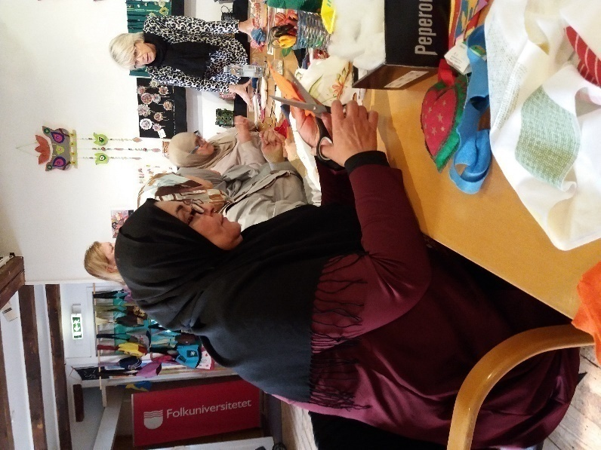

**Roda Korset language cafe**



**Short way for migrants integrate in Swedish community**

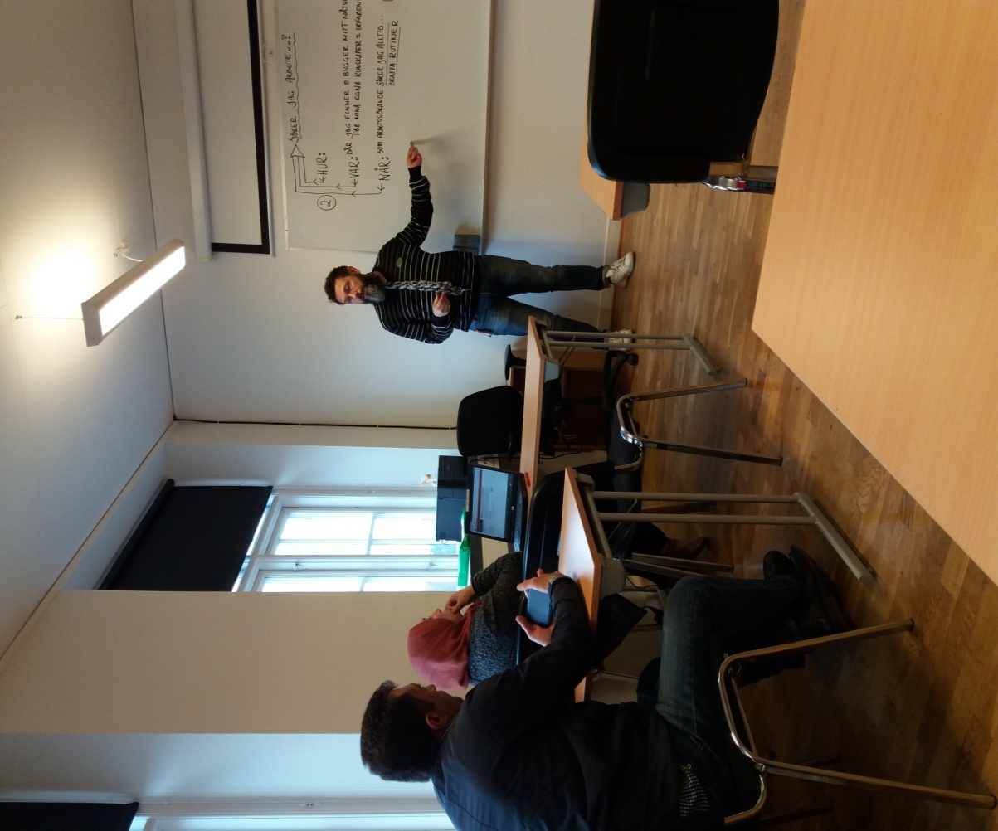

**Work with immigrants in Latvia**

**The Accommodation Centre for Asylum Seekers**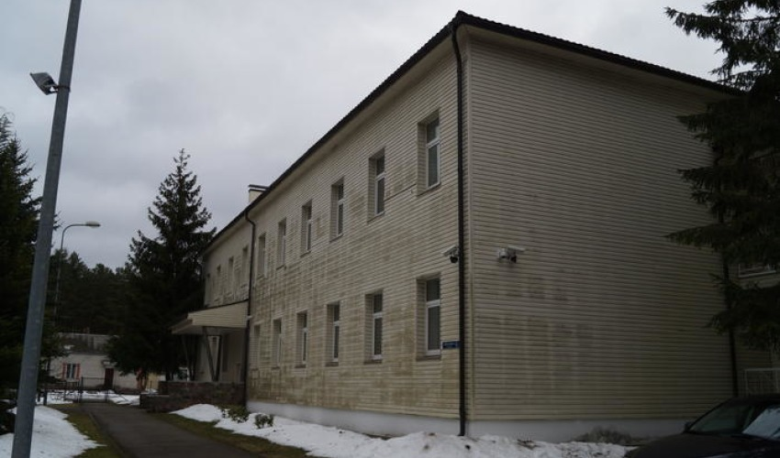

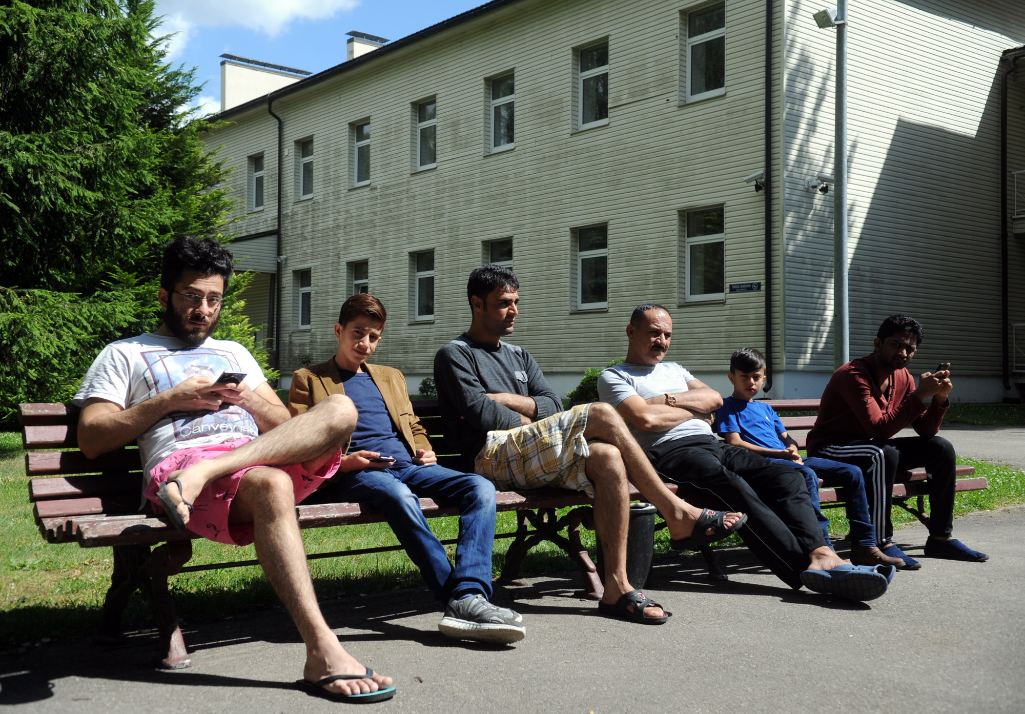

**NGO "Shelter "Safe House""**

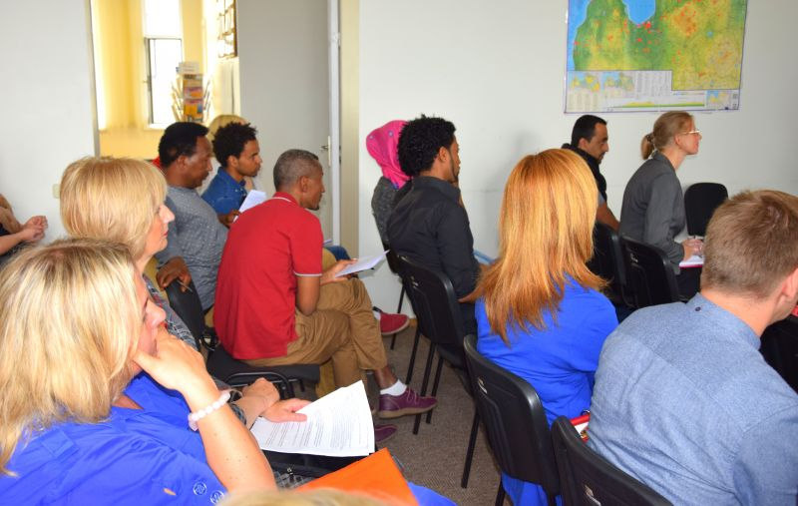

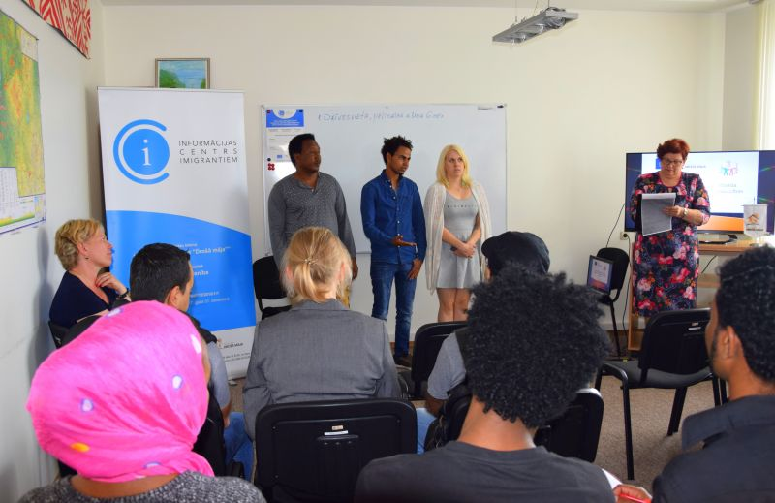

**Training possibilities for immigrants in Latvia**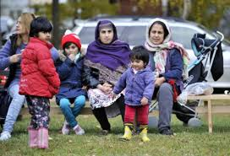

**Current activities at Jelgava Trade secondary school:**

1. Two educational programs without restrictions of former education have been performed;

* A Hairdresser –length of studies 1 year, 2nd professional qualification level;
* A cook – length of studies 1 year, 2nd professional qualification level;

1. Studies are performed in Latvian,
2. After lessons individual consultations in Latvian are available (financed by ESF project),
3. Transport expenses are paid by the school.

