a

**Potential problems in our school:**

* Teachers cannot speak English;
* Refugees do not even speak English;
* Illiteracy among refugees;
* No information about certifications of previous education
* Different world perception depending on gender

**Solutions:**

* Language courses for teachers,
* Courses on culture and work in multicultural environment
* Additional cultural and social events after school activities
* An interpreter at schools;
* The school should be warned on time about immigrant training to develop and receive licence of special programmes (without secondary education general subjects)

**Contact information**

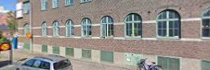

Föreningsgatan 1, 291 33 Kristianstad, Sweden

[www.folkuniversitetet.se](http://www.folkuniversitetet.se)

______________________________

Jelgava Technical school

Pulkveža O.Kalpaka str.37, Jelgava, LV-3001, Latvia

[www.jelgavastehnikums.lv](http://www.jelgavastehnikums.lv)

info@jelgavastehnikums.lv

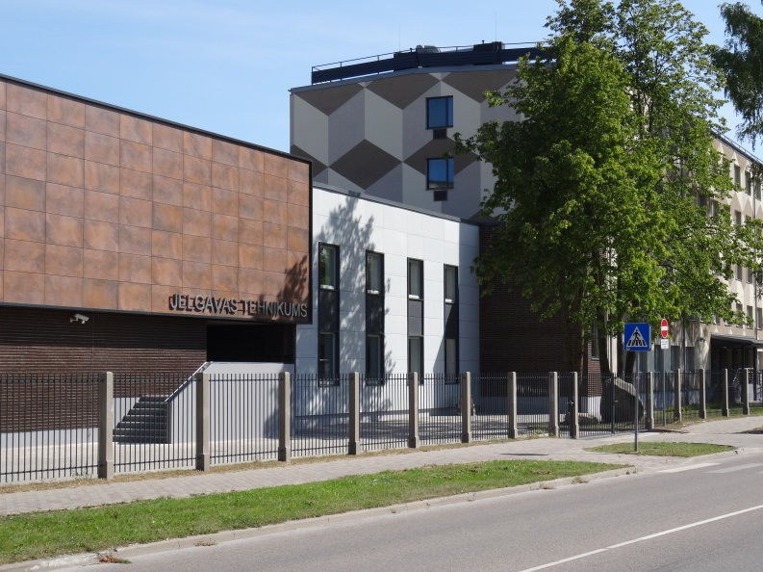





**Better Training for Adults**

**NPAD-2017/10090**

