WELDING

Technical Description

Set of tasks

INTRODUCTION
The name of the skills competition is welding.

THE CONTENT, RELEVANCE AND SIGNIFICANCE OF THIS DOCUMENT

„Set of tasks technical descriptional“ is designed to understand the main technical organization procedures and tasks of Professional mastery competition „Balticskills“.

All competition organizers and participants must have analyzed the „Set of tasks technical descriptional“.

In the event of any conflict within the different languages of the Technical Descriptions, the English version takes precedence.

PROFESSION DESCRIPTION

The participant performs practical work, which consists of different plates and tubes installation and it needs to weld different welding positions.

During the practical work, the participant follows the rules of work safety equipment.

ASSESSMENT STANDARD SPECIFICATION

The assessment standard provides a skills assessment methodology.

Each section is assigned a percentage of the total marks to indicate its relative importance within the assessment standards specification. The sum of all the percentage marks is 100.

Only the skills listed in the assessment standards specification table will be assessed during the Professional mastery competition „Balticskills.
Assessment standards specification
Competencies |  | Percentage
1. | Work organization and self-management | 25
The individual needs to know and understand:

- the standards and laws relating to the health, safety, security and hygiene in the welding industry,

- the standards and regulations relating to safe working practices, accident procedures, evacuation procedures and escape routes,

- the range, use and maintenance of personal protective equipment used in the industry for any given circumstances,

- the safety recommendations and regulations relating to the welding of materials in all conditions including wet/damp areas, confined spaces and situations where oxygen levels are likely to be below those required for safe working,

- the recommendations, regulations and procedures required to prevent explosion, fire or combustion in all circumstances,

- the dangers of slips, trips and falls while engaged in welding operations,

- the requirements and effects of welding production for the environment and sustainability issues,

- basic mathematical manipulation and unit conversion geometrical principles, techniques and calculations.

The individual shall be able to:
- work safely with regard to themselves and others in all circumstances,

- recognize hazardous situations and take appropriate actions with regard to their own and others safety,

- follow correct procedural processes when working in dangerous and semi-dangerous environments,

- maintain a clean working environment,

- store used materials in relevant containers for recycling and sustainability,

- make essential connections for specific welding procedures being undertaken.

2. | Preparation for welding | 5
The individual needs to know and understand:
- the interpretation of welding/engineering drawings and weld symbols,

  - the classification and specific uses of welding consumables including:
- colour coding of gas cylinders,
- coding and designation of welding rods,
- diameters and specific use of welding wire,
- choice and preparation of welding electrodes,
- forms of edge preparation process available,

  - the correct machine settings to be aligned to:
- welding polarity,
  - welding position,material,
  - material thickness,
  - filler material and feed speed,
  - any fine adjustments needed to machine hardware, TIG electrode shape, wire type and diameter etc.,
  - the characteristics and properties of filler materials,
  - the methods of edge preparation to align with joint profile, strength, material and drawing specification,
  - welding parameters/variables for specific tasks,
  - effects of changes in welding variables/ parameters of completed weld.

The individual shall be able to:

  - prepare material edges as per drawing specification,

  - select welding consumables by use, size, positional characteristic and material being welded,

  - remove surface contamination prior to welding,

  - select correct filler material and size to suit materials being welded,

  - adjust welding equipment with consideration to welding parameters/variables,

  - set up welding equipment to manufacturers specification including (but not limited to):

- welding polarity,
- welding amperage,
- welding voltage,
- wire feed speed,
- travel speed,
- travel/electrode angles,
- mode of metal transfer.

  - prepare material edges in line with specification and drawing requirements.

3. | Welding materials | 10
The individual needs to know and understand:

  - the mechanical and engineering properties of carbon steels,

  - the mechanical and engineering properties aluminium and its alloys,

  - the mechanical and engineering properties of stainless steel,

  - selection, and storage of welding consumables,

  - correct storage and handling of welding consumables,

  - selection and safe use of electrical power tools,

  - the control of material and welding operations in environmental protection.

The individual shall be able to:

- use materials with consideration to their mechanical and engineering properties,

- store welding consumables correctly with reference to type, use and safety considerations,

- select and prepare materials with reference to drawing material list and welding symbols,

- prepare materials according to their properties and surface characteristics,

- use electrical power tools safely to cut, grind and prepare / finish welds,

- work efficiently within time limits set.

4. | Welding Processes | 60
The individual needs to know and understand:
- specific terminology used in the welding industry,

- the precautions necessary for the safe use of power tools and welding equipment,

- recognition and selection of welding consumables,

- the selection, use and techniques of the various welding process used,

- the specific methods used in shielding the weld area from contamination,

- the selection of gasses used for shielding and purging,

- weld positions, weld angles and electrode travel speeds,

- methods of distortion control in steels, alloys and aluminium,

- appropriate methods of finishing completed welds,

- the techniques for efficient stop / starts,

- the selection, adjustment and safe operation of electrical power tools,

- methods and processes used in transfer of weld metal to the weld area,

- weld defects and their appropriate rectification,

- the importance of weld metal cleanliness in weld quality.

The individual shall be able to:
- make welded joints in relation to international specifications,

- interpret welding terminology to complete task to specification,

- maintain welding equipment to deliver quality results,

- select and adjust welding equipment to provide appropriate methods of weld metal transfer to the weld area,

- select correct welding consumable to suit process and conditions,

- perform welding in all positions on pipe and plate for all nominated welding processes as detailed,

- weld steel plate and sections using the manual metal arc welding process,

- weld steel plate and sections using the gas metal arc welding process,

- weld stainless steel plate and sections using the Gas tungsten arc welding process,

- weld aluminium plate and sections using the gas tungsten arc welding process,

- dress welds using wire brushes, scrapers, chisels etc.
- perform stop / starts to weld processes,
- dress completed welds,
- work accurately to drawing specification,
- produce welds to meet drawing and legislative specifications,
- correct weld faults and inclusions to maintain quality,
- check completed work against drawing requirements to reflect accuracy, square and flatness where necessary,
- demonstrate the preparation and safe use of electrical power tools and equipment,
- carry out appropriate procedures to control heat input,
- recognise weld defects and take appropriate action to rectify them,
- take appropriate actions to ensure that weld metal cleanliness is maintained.

 | TOTAL | 100%

ASSESSMENT PRINCIPLES

All assessment will be governed by explicit benchmarks, referenced to best practice in industry and business. Competition tasks is the assessment vehicle for the skill competition, and also follows the Standards Specification.

SKILLS ASSESMENT CRITERIA
Criteria for evaluating the practical part of the part developed for the competition during the testing process:
Explanation of professional competencies - skills, abilities and attitudes | Points
-Occupational safety rules are fully observed and the workplace is arranged before and after the task | 6
- Occupational safety regulations are generally observed, but insignificant deviations from the requirements of the agenda are allowed | 3
- Allows significant violations of work safety regulations and does not tidy up the workplace | 0
Evaluation of welded product performance quality

- Adhesion of parts
- Adhesion of welded parts is performed without deviation of parts in the plane and space | 4
- Deviation of parts either in the plane or in space is allowed | 2
- Mutual deviation of parts in both plane and space | 0
- Start and end of the seam
-Correctly started and finished seam | 2
-Properly started or finished seam | 1
-The seam is not started and completed correctly | 0
- Correspondence of the geometrical dimensions of the seam to the connection parameters
- Conforms the entire length of the seam | 8
-Conforms over 50% of the seam length | 4
-Conforms up to 50% of the seam length | 2
-Does not fit the entire length of the seam | 0
- Welding (butt joint)
-Welding is performed along the entire length of the seam | 22
-Welding performed over 75% of the seam length | 16
-Welding is performed from 50% to 75% of the seam length | 8
-Welding is performed in separate sections of the seam | 4
-No wiring throughout the seam | 0
- Incineration/burn-in (butt joint)
-No burn-in | 8
-There is a burn-in with suspension | 3
-There are several burn-ins with suspension | 1
-It is burn-in with an opening | 0
- Incineration/burn-in (in corner and T-joints)
-No burn-in | 2
-There is a burn-in with suspension | 1
-It is burn-in with an opening | 0
- Cut in the base metal
-No cuts | 6
-There are individual small incisions (up to 5 mm in length) | 4
-There are individual continuous cuts up to 50% of the seam length | 2
-There are individual continuous cuts above 50% of the seam length | 1
-Cuts along the entire length of the seam | 0
- Pore seams in metal
-No pore along the entire length of the seam | 4
-There are up to two pores along the length of the seam | 2
-There are three or more pores along the length of the seam | 0
- Cracks in the crater
-No crack | 1
-There are cracks | 0
- Burn on the base metal
-No burn on base metal | 2
-There is a burn on the base metal | 0
- Splatter
-No splatter | 3
-Splatter are partially removed | 1
-Splatter are and have not been cleaned | 0
- Slag (oxide layer)
-Slakes (oxide layers) are not along the entire length of the seam | 3
-The slag (oxide layer) is partially removed | 1
-The slag (oxide layer) has not been cleaned | 0
- Metal flows
-There are no metal flows | 2
-There are metal flows | 0
- Conformity of the welded product to the task given in the detail drawing
- The correct welding techniques and the specified joint positions in the room have been applied. The part is welded according to the given drawing. | 10
-The correct welding techniques have been used. All welded positions in the room do not correspond to the drawings. | 5
-No appropriate welding techniques used. The welded positions in the room do not correspond to those given in the drawing. | 0
Maximum score - 220

SKILL ASSESSMENT PROCEDURES

Visual and pressure control where we chek whether the part holds air.

Competition tasks:
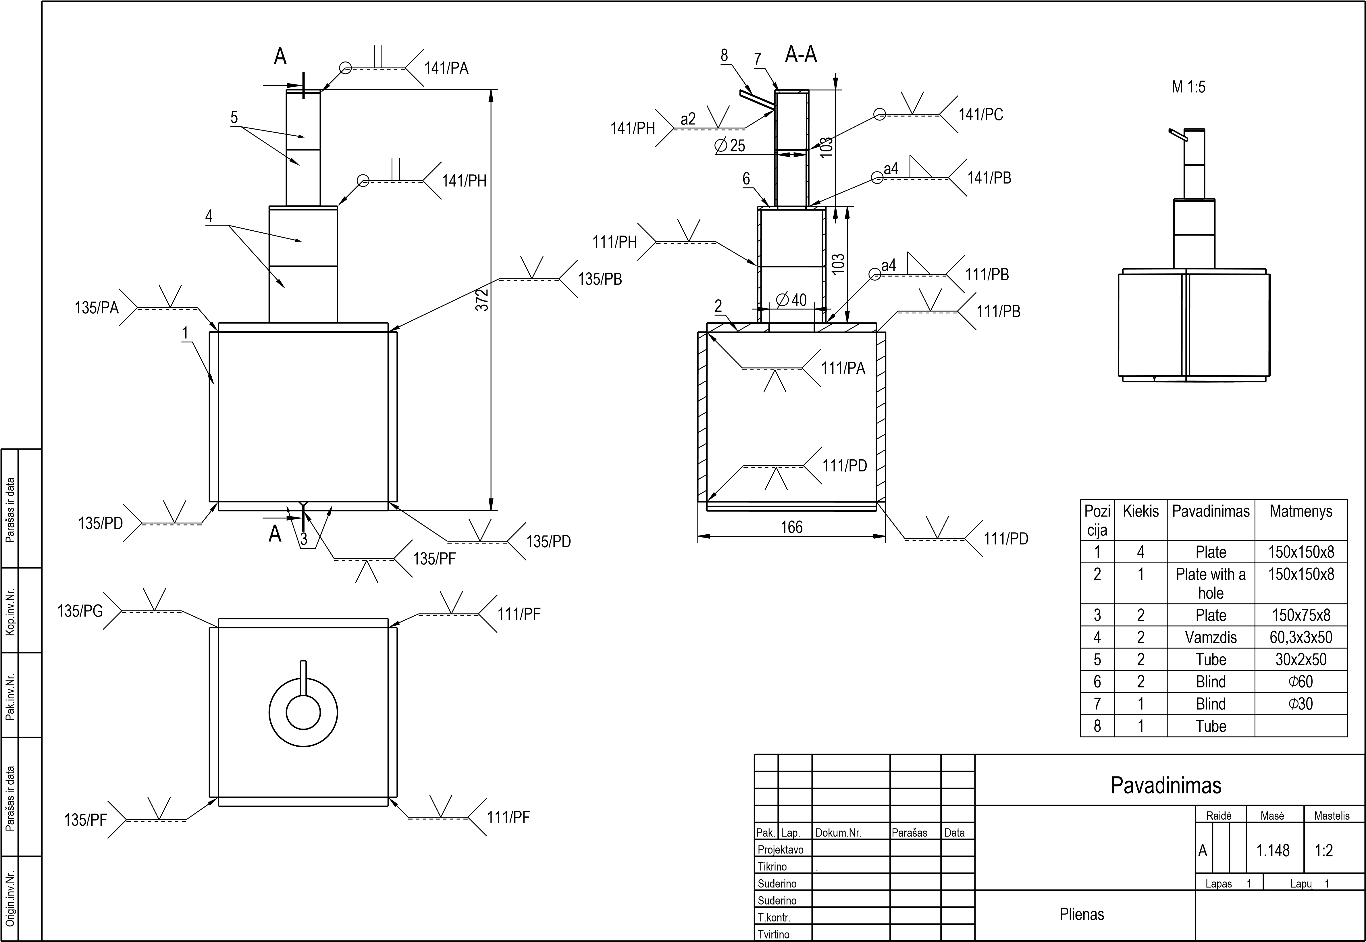
Notes:

