a

Potential problems in our school:
- Teachers cannot speak English;
- Refugees do not even speak English;
- Illiteracy among refugees;
- No information about certifications of previous education
- Different world perception depending on gender

Solutions:
- Language courses for teachers,
- Courses on culture and work in multicultural environment
- Additional cultural and social events after school activities
- An interpreter at schools;
- The school should be warned on time about immigrant training to develop and receive licence of special programmes (without secondary education general subjects)

Contact information
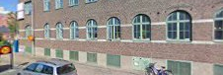
Föreningsgatan 1, 291 33 Kristianstad, Sweden
www.folkuniversitetet.se
______________________________
Jelgava Technical school
Pulkveža O.Kalpaka str.37, Jelgava, LV-3001, Latvia
www.jelgavastehnikums.lv
info@jelgavastehnikums.lv
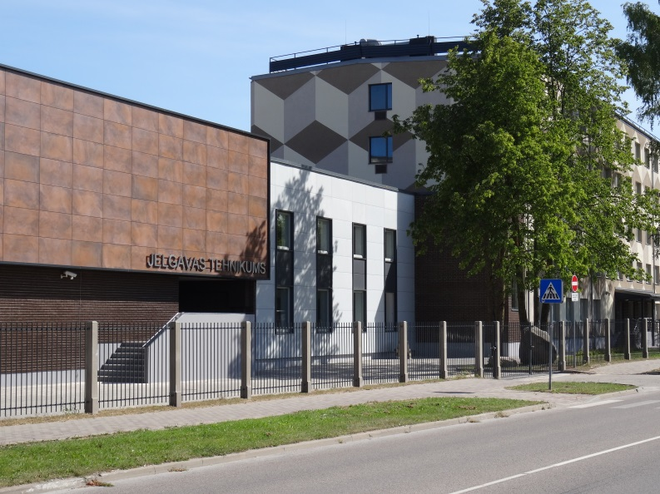



Better Training for Adults
NPAD-2017/10090

